Ex. No. 1 | TITLE OF THE EXERCISE
YouTube Link
Date of Exercise | DD.MM.YYYY

Aim
To write and execute a Java program to demonstrate the use of loops such as for, while, and do-while for repeated execution of statements.

Description
Loops in Java are used to execute a block of code repeatedly based on a given condition. Java provides three main types of loops: 1. for loop – Used when the number of iterations is known. 2. while loop – Used when the condition is checked before each iteration. 3. do-while loop – Executes the statements at least once before checking the condition.

Program
public class LoopsDemo {
public static void main(String[] args) {
// For loop
System.out.println("For Loop:");
for (int i = 1; i <= 5; i++) {
System.out.println(i);
}
// While loop
System.out.println("\nWhile Loop:");
int j = 1;
while (j <= 5) {
System.out.println(j);
j++;
}
// Do-while loop
System.out.println("\nDo-While Loop:");
int k = 1;
do {
System.out.println(k);
k++;
} while (k <= 5);
}
}

Output Screenshot
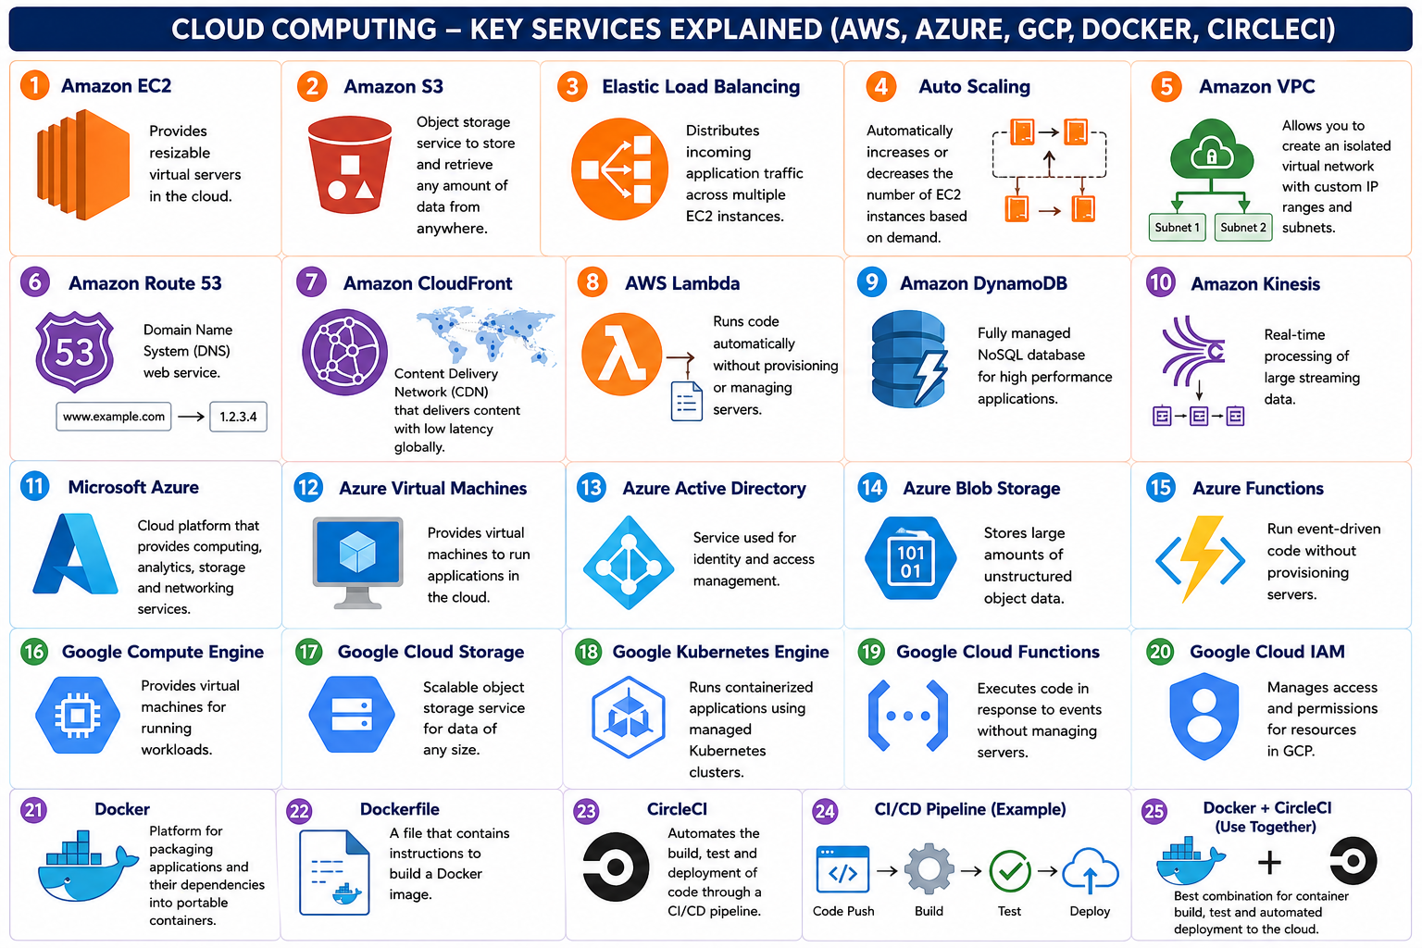

Result
The Java program was successfully executed and the for loop, while loop, and do-while loop were demonstrated. Each loop printed the numbers from 1 to 5 successfully. 1/2

